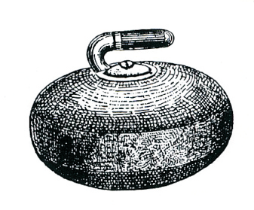
INVERKEITHING CURLING CLUB

APPLICATION FOR MEMBERSHIP

To The Secretary
Inverkeithing Curling Club

Dear Sir

I wish to apply to join Inverkeithing Curling Club.

Yours faithfully

Name ______________________________________________

Signed _____________________________________________

Date _______________________________________________

We, the undersigned, propose and second the above for membership to the Club

Proposer Name ______________________________________

Signed _____________________________________________

Seconder Name ______________________________________

Signed _____________________________________________

Details of Applicant (Block letter please)

Full Name _______________________________________

Address _______________________________________

______________________________________

______________________________________

Tele No (Home) ______________________________________

Tele No (Business) ____________________________________

Mobile No ___________________________________________

E-mail ______________________________________________

